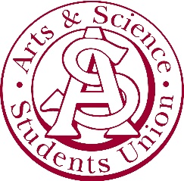

Arts & Science Students’ Union Agenda
September 28th, 2020
5:09 pm

WebEX

Regrets: Brock Derbyshire, Sahil Soota

1. Recognized Treaty 6 Territory

2. Adoption of agenda
- Motion to adopt agenda by Palak
  - I make a motion to adopt this agenda
- Seconded by
  - Lucas

3. Approve Last Meeting Minutes
- Minutes were approved

4. Executive Reports
4.1 Presidential report
- AGM is approaching
- Meeting next week cancelled, schedule will shift to continue bi-weekly

4.2 Committee reports

5.2.1 VP Dirk-Pothier
- Event planning: Halloween Pumpkin carving, Spooky BOOquets.
5.2.2 VP Njaa
- Scholarship applications are coming up.
5.2.3 VP Kobashi
- Lanyards Selling hoodies and lanyards for a small profit.

5.2.4 VP Azevdo
- Advertising the AGM.

5. Students’ Councils Report
5.1 Member of Students’ Councils report
- Attended meeting with the USSU.
6. Other Business
- No other business

Meeting Adjourned

