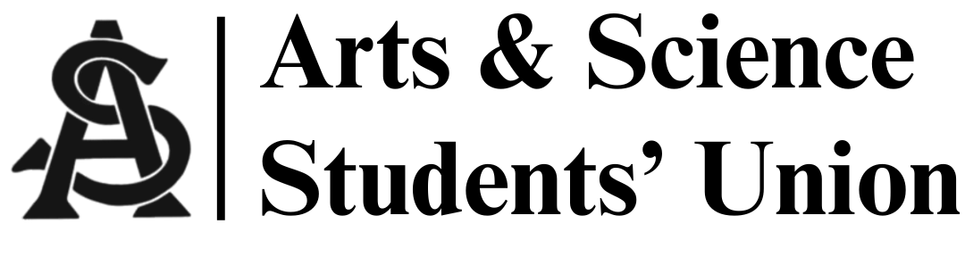
Meeting Minutes
November 5, 2025
5:30 PM | Arts 134

- Call to Order
-5:31 p.m.

- Introductions:
- Adoption of Agenda
- Adoption of Last Meeting’s Minutes
- M/S: Blue / Fala
- Land Acknowledgement
- Motion for informality
- M/S: Tiffany / Blue

- Reports
  - President’s Report
- AOC Meeting
- AGM USSU November 20, 2025
- Career Services coming November 19, 2025
- Pub crawl ticket live Friday
- Sponsorships sent out

  - VP Internal Affairs Report
- Cleaning storage room after break
- Refreshing Council Member Policy:
  - Show up to three meeting in a row to be a council member
  - Must email if absent
- Merch: Sweaters (possibly)
- Budget Report:
  - +$246.25
  - -$545.96

  - VP Academic Affairs Report
- Academic Integrity Forum:
  - Last forum of the term
  - Forum will resume in January
  - Survey sent out for new topic
    - Brainstorm new topics (this term was Artificial intelligence and generative AI usage)

  - VP Marketing Report
- Stats same
- Making reels for gala
- Gala post will be ready after break

  - VP External Affairs Report
- Pub crawl November 21, 2025
- Gala committee and finalizing

  - MSC Report(s)
- Plans to change Campus Drive
  - Change / add bus drop offs
  - Remove two right turns
  - Plan will take 2 years to be implemented
  - Goal: reduce lane traffic

- Other Business
- Dean meeting last Friday:
  - Going to give some funding for gala
  - Study abroad / Taught abroad = possibly cancelled due to finances
  - Change of exam hours will not be implemented for two years
  - Debate night at Louis tomorrow night
  - Christmas Decorations:
    - $100 for lounge decoration
    - M/S: Owen / Fala

- Adjournment
- Meeting adjourned at 5:46pm

