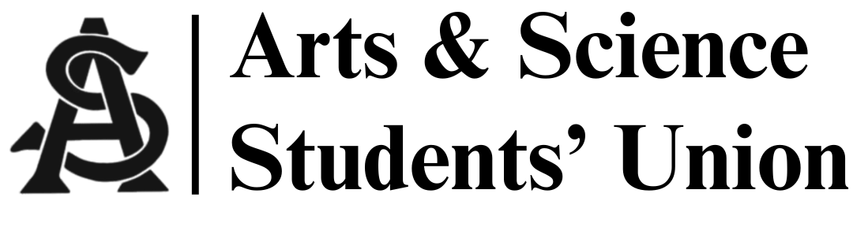
Meeting Minutes
October 15, 2025
5:00 PM | Arts 134

- Call to Order
-5:02 p.m.

- Introductions:
- Adoption of Agenda
- Adoption of Last Meeting’s Minutes
-Siya/Mia
- Land Acknowledgement
- Motion for informality
- Mika/Aryana

- Reports
  - President’s Report
- Murder mystery October 28, 2025
- Pub crawl Nov 21, 2025
- Gala January 16th (tentative)
- Dean meeting October 31st
- Ideas for:
  - Gala sponsorships / suggestions
- Meeting with student group collaboration

  - VP Internal Affairs Report
- Monthly budget report:
  - Fixed income from monthly report of $1,300 to $2,675
- Next week’s meeting is in Arts 134

  - VP Academic Affairs Report
- Results of academic survey
- Total responses = 38
- Exam file (55% of people unaware of this resource, 45% use resource)
- Academic advising (45% found helpful, 12% unhelpful)
- Academic hearing:
  - Misuse of AI

  - VP Marketing Report
- Everything decreased except interactions
- Poster for event and pub crawl will be completed on weekend
- Tabeling for upcoming event

  - VP External Affairs Report
- Murder mystery night
  - October 28, Tuesday
  - Options discussed
  - Photo booth
  - Motion for budget = $400.00
- Aryana/Emma
-passed
  - MSC Report(s)
- Discussed dental plan options
- Gender affirming care in talks of being added to benefits

- Other Business
- History panel of professors – Arts 101
- PSSA debate night November 6th @7pm
- Adjournment
- Meeting adjourned at 5:24pm

