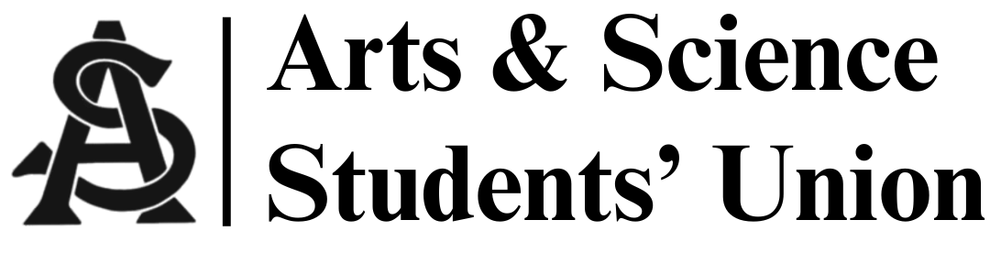
Meeting Minutes
October 8, 2025
5:00 PM | Arts 134

- Call to Order
- 5:02pm

- Call for Quorum

- Adoption of Agenda

- Adoption of Last Meeting’s Minutes
- Maya/Fala passed
Motion for informality
-Siya/Colton
- Introductions

- Reports
  - President’s Report
- Faculty council report
- (AOCP) Association of Contingency Presidents meeting:
  - Dean Milne, USSU, ASSU, and department of student association meetings are looking to happen soon
    - Looking to discuss work placements, PD, etc.
  - USSU AGM happening Nov. 20th in Arts 241 (there will be pizza &pop) (you should all go)
  - Dee Hene, the U of S CFO, wants to meet about funding from a students perspective
  - Next AOCP meeting will have a guest to discuss AI usage within the colleges
  - VP Internal Affairs Report
- Monthly budget report:
  - -893.94
  - +2,675
- Next week's meeting is in Arts 134
  - VP Academic Affairs Report
- Academic survey still on for another week
- Academic integrity forum:
  - Orientation before school starts?
  - Required modules or class?
  - Library support?
  - VP Marketing Report
- Views on Instagram went up
  - VP External Affairs Report

  - MSC Report(s)
- Last meeting for old president
- Gender affirming care might be added to health care
  - Vote on that has not happened yet
- Other Business
- CFO talks about getting student fees of about $3 for ASSU
- PSSA debate night November 5th @7pm
- Pharmacy career fair happening Oct. 15th
- 8. Adjournment

- Meeting adjourned at 5:30pm

