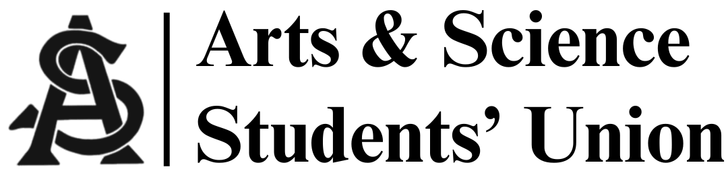
Meeting Minutes
Date January 28th, 2026
Time 5pm | Location Arts 143

- Call to Order 5:01pm

- Call for Quorum

- Adoption of Agenda
- Owen/Blue
- Adoption of Last Meeting’s Minutes

- Motion for informality
- Blue/Siya
- Introductions

- Reports
  - President’s Report
-Sexy bingo feb. 11th @6pm
- Food
- Bingo cards
- $400
Mia/Owen passed
- AGM date upcoming

  - VP Internal Affairs Report
-Amount made from Gala will be told next week

  - VP Academic Affairs Report
- Conversation on Tuition meeting Feb. 9th

  - VP Marketing Report
-stats when up from 42.2k to 121.1k
-Tabling for Sexy bingo possible next week
  - VP External Affairs Report
-18 out of 20 Art work sold
-Total income from auction: $1,038.95
-ASSU commission: $269.55

  - MSC Report(s)
- Undergraduate research symposium feb
- USSU meeting tomorrow will discuss tuition rates
- Indigenous symposium feb 6th
- Other Business
- Model UN club starting up
- Global brigades Galentine’s Event on Feb. 6th
- 8. Adjournment at 5:19pm

