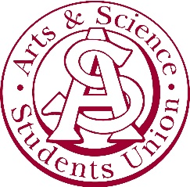

Arts & Science Students’ Union Agenda
September 7, 2021 | 5:02 pm

Arts 218 | Zoom

- Recognized Treaty 6 Territory

- Introductions
- Motion to Adopt the Last Meeting Minutes
    - Motioned by Sahil
    - Seconded by Zach
    - No amendments
    - Motion Passes
  - Introductions of the executive team and new members

- Adopt Agenda
- Motion to Adopt the Agenda
    - Motioned by Sahil
    - Seconded by Zach
    - No amendments
    - Motion Passes

- Executive Reports

  - Presidential reports
- We have lanyards and stickers for sale now
- Feel free to stop by and use our resources such as our free condoms
- Dean Peta’s town hall
  - Wednesday January 26 at 3:30 pm (over zoom)
  - Thursday February 3 at 11 am
- No information about classes going back to in person
- Booster shot promotion campaigns are continuing

  - Committee reports

    - VP Dirk-Pothier
    - We will be reworking the budget for the next meeting
    - We have more space in the budget since we are going online

    - VP Soota
    - Associate Dean of Student Affairs is cautiously optimistic that we will be returning to in person classes – that is his opinion
    - The scholarship budget will be decided by next week

    - VP Azevedo
    - No updates

    - VP Shah
      - Will be planning more events soon
      - Please come to the online events, a great way to interact with everyone

- Other Business
  - Veronica
    - LSAT prep with the Princeton review
    - If you have any questions reach out to Veronica about this
  - Zach
    - Improv Night is happening again, so please come out
  - Sahil
    - Lucas’ birthday
  - Ishita
    - YHY Saskatchewan is recruiting so please apply
    - Access to free resources and amazing brand partnerships you can take advantage of
    - February 18 is when the applications are due

- Meeting Adjourned
  - Meeting adjourned at 5:58 pm

